# **Caremark.com – View My Plan (Past, Present & Future) Website**

|  |
| --- |
| **Scenario/Member Statements** |

I am logged into my account, and I am seeing my plan from last year. How can I access my new benefits?

I had a plan last year and need to get my financial summary for my taxes. Can I still access that plan?

|  |
| --- |
| **View My Plans** |

1. Make sure you have looked at the “view my plans” (past present and future plans) **BEFORE** troubleshooting for [Log in](https://thesource.cvshealth.com/nuxeo/thesource/#!/view?docid=422c7044-7196-4ed4-a10a-8037b579a4a9) and [Registration](https://thesource.cvshealth.com/nuxeo/thesource/#!/view?docid=002cc829-ccea-4b1c-bd0c-33ef8ddfd6ba).

* Members who have or have had more than one plan with CVS Caremark in the past 36 months will be displayed on the dashboard titled “**View my plans**”.
* This allows members to access any of the plans they want to access and sign in with the same username and password.

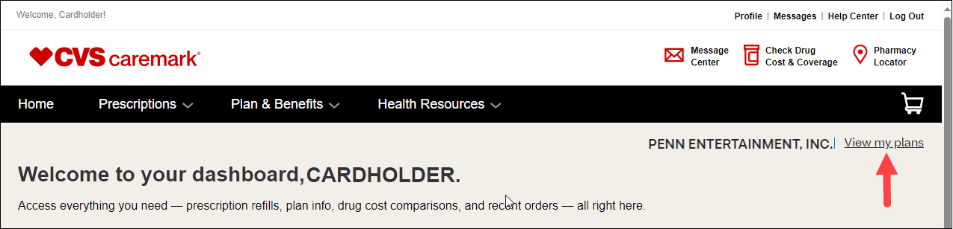

1. If member signs in and their account is inactive or not their current plan, ask member to click “**View my plans**”.

* Members will see current, upcoming, and past plans in the last 36 months based on the termination date.
* If the member wants to access or view another plan, they simply select the plan and sign in again using the same username and password.

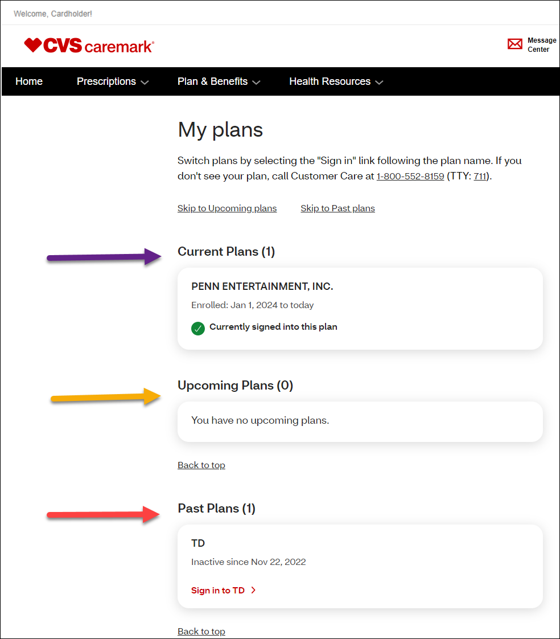

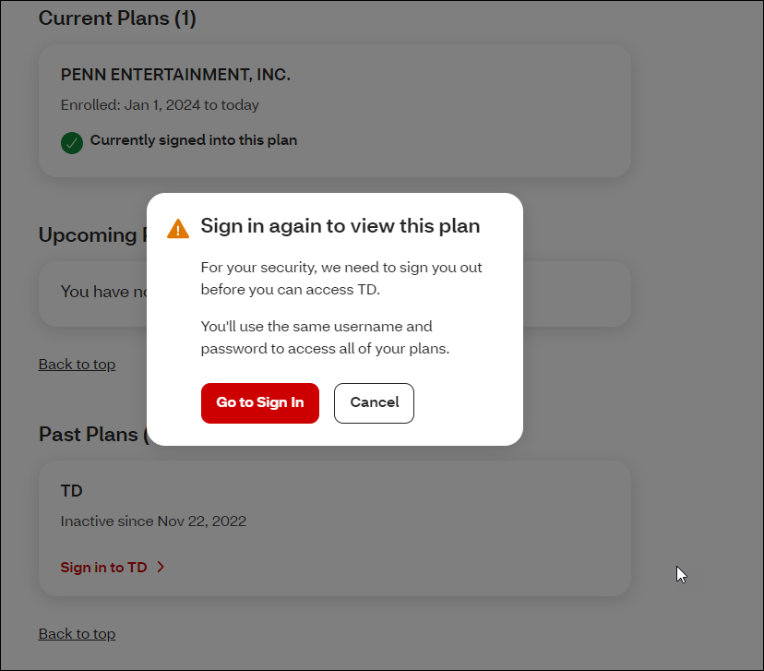

**Note:** Do **NOT** delete a member’s registration from an inactive account to allow the member to access their active account. Members can simply select and sign into any of their accounts using the same username and password.

* When a member has selected another plan to view and has signed in using the same username and password, they can always go back to “View my plans” from the dashboard, select their default plan, and sign in again using the same username and password.
* If the member signs out of Caremark.com and signs in again later, they will be signed into their default plan.

|  |
| --- |
| **Related Documents** |

[Caremark.com - Common Member Assistance Call Types Index](https://thesource.cvshealth.com/nuxeo/thesource/#!/view?docid=947b0b38-401d-4b18-a08e-60348558a9b9)

**Full Details Document:**  [Caremark.com Log in and Registration (Carrier to Carrier) Enhancements](https://thesource.cvshealth.com/nuxeo/thesource/#!/view?docid=dd7f8b9f-cf1b-4f7c-86f7-ac6e0a015452)

Not To Be Reproduced Or Disclosed to Others Without Prior Written Approval

**ELECTRONIC DATA = OFFICIAL VERSION / PAPER COPY = INFORMATIONAL ONLY**